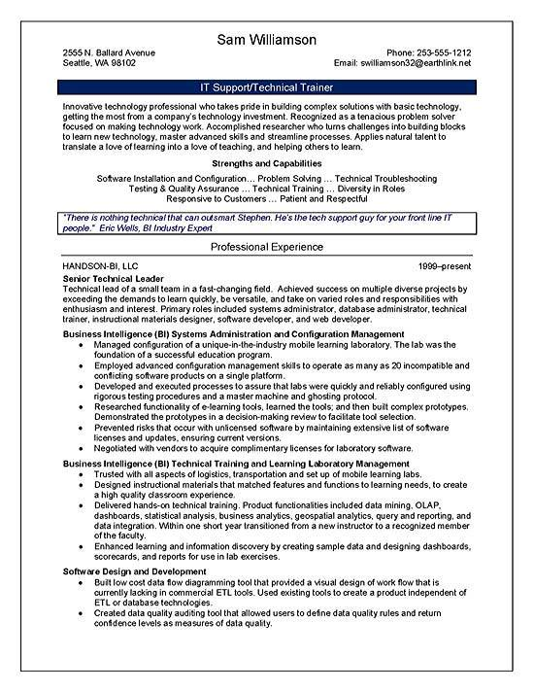
Sam Williamson
2555 N. Ballard Avenue Seattle, WA 98102
IT Support/Technical Trainer
Phone: 253-555-1212 Email: swilliamson32@earthlink.net
Innovative technology professional who takes pride in building complex solutions with basic technology. getting the most from a company's technology investment. Recognized as a tenacious problem solver focused on making technology work. Accomplished researcher who turns challenges into building blocks to learn new technology, master advanced skills and streamline processes. Applies natural talent to translate a love of learning into a love of teaching, and helping others to learn.
Strengths and Capabilities
Software Installation and Configuration... Problem Solving... Technical Troubleshooting Testing & Quality Assurance... Technical Training... Diversity in Roles
Responsive to Customers... Patient and Respectful
"There is nothing technical that can outsmart Stephen. He's the tech support guy for your front line IT people." Eric Wells, BI Industry Expert
Professional Experience
HANDSON-BI, LLC
Senior Technical Leader
1999-present
Technical lead of a small team in a fast-changing field. Achieved success on multiple diverse projects by exceeding the demands to learn quickly, be versatile, and take on varied roles and responsibilities with enthusiasm and interest. Primary roles included systems administrator, database administrator, technical trainer, instructional materials designer, software developer, and web developer.
Business Intelligence (BI) Systems Administration and Configuration Management
• Managed configuration of a unique-in-the-industry mobile learning laboratory. The lab was the foundation of a successful education program.
. Employed advanced configuration management skills to operate as many as 20 incompatible and conflicting software products on a single platform.
• Developed and executed processes to assure that labs were quickly and reliably configured using rigorous testing procedures and a master machine and ghosting protocol.
Researched functionality of e-learning tools, learned the tools; and then built complex prototypes, Demonstrated the prototypes in a decision-making review to facilitate tool selection.
Prevented risks that occur with unlicensed software by maintaining extensive list of software licenses and updates, ensuring current versions.
Negotiated with vendors to acquire complimentary licenses for laboratory software.
Business Intelligence (BI) Technical Training and Learning Laboratory Management Trusted with all aspects of logistics, transportation and set up of mobile learning labs. Designed instructional materials that matched features and functions to learning needs, to create a high quality classroom experience.
• Delivered hands-on technical training. Product functionalities included data mining, OLAP. dashboards, statistical analysis, business analytics, geospatial analytics, query and reporting, and data integration. Within one short year transitioned from a new instructor to a recognized member of the faculty.
• Enhanced learning and infomation discovery by creating sample data and designing dashboards, scorecards, and reports for use in lab exercises.
Software Design and Development
• Built low cost data flow diagramming tool that provided a visual design of work flow that is
currently lacking in commercial ETL tools. Used existing tools to create a product independent of ETL or database technologies.
• Created data quality auditing tool that allowed users to define data quality rules and return confidence levels as measures of data quality.

